Troubled Archives

The story of how an individual artistic research into archives becomes a collective and at times community driven project

Author biography: Troubled Archives is a collective name for the collaboration between [Rokia Bamba](https://www.mixcloud.com/leabel/), Brenda Bikoko, [Loes Jacobs](http://nadine.be/), [Michael Murtaugh](http://vandal.ist/), [Peggy Pierrot](http://peggy.pierrot.work/), and [Antje Van Wichelen](http://primitives.constantvzw.org/).

## 1997_

ANTJE: I find in a newspaper a story of a taxidermied man exhibited in a museum. The story sticks with me and in 2011 it is the first story in my research blog on how racist stereotypes are constructed. [1]

## 2012_

Visiting institutional archives I discover large collections of pre-colonial and colonial 19th century photographs made by western photographers in an ever failing attempt to categorize people into races and an hierarchical order.

*Together these collections form the ‘filthy’ archive of how the colonizing west has been busy constructing a dehumanizing portrait of all peoples that were to be dominated. Today this filthy archive is more a witness of the mechanisms of this construction than that it could ever pretend to be a portrait of any of the photographed individuals or societies; it tells us more about the people behind the camera than of what they were staging in front of the lens.*

That is my starting point when dealing with these archives. My aim is to, as much as possible, corrupt the original objectifying goals of these photographic series.

## 2015_

While looking for ways to work with these photographs as an animation filmmaker, I research into the materiality of collodion and silver print photography, which leads me to black and white celluloid filmmaking.

I become a member of Labo BxL and learn the methods of manual flatprinting that allows me to develop the artistic language of 21C/19C_Procedures for Anthropometric Image Reversal.

That artistic language has become one of sparsely giving information, allowing light grey forms to appear in a white image, quickening the pace and slowing down again, lingering on images with almost nothing to see, activating the eye searching for information, activating the brain, inciting it into a very personal train of thought about these old photographs and what they mean today, in a tactile experience. The manual production methods steer the experience away from the judging gaze of our education, and animate the haunted figures towards a new, resilient liveliness.

The struggle with my position as a white artist tackling this sensitive material - how to work with these photographs without repeating the violence they behold - leads me to a series of conversations with scientists and artists who are already working with these topics.

People of colour are not sitting waiting for you and your initiative, you have to be aware of that. (**Bambi Ceuppens**)

The viewing of these images will enter differently into different bodies. The impact on a black body can be very violent. (…) The problem is not, that you as a white artist create this work, (…) the problem is that in the meantime a black artist might be asking for this same access and funding, and not get it. (**Pascale Obolo**)

ANTJE: Shyly, I confront sound-artist **Rokia Bamba** with the images from the archives I found. She later says : “It took me three months to recover from seeing those images”.

ROKIA: J’étais très heureuse de la proposition de collaborer avec Antje, j’avais l’impression que nous nous étions attendues, notre relation demeure particulière, je pense, nous nous connaissons depuis tellement d’années, notre amitié a perduré avec le temps et nos parcours de vie nous ont amené à nous revoir, j’ai la forte impression qu’elle m’avait attendue…

Trois mois pour m’en remettre, trois mois ou je voyais les images, les photos, défiler devant mes yeux, les unes après les autres, portraits, visages, corps nus de femmes, d’hommes, d’enfants, dirigés, manipulés comme des marionnettes, des pantins désarticulés, mais toujours vivants, sur le moment. Trois mois pour comprendre ou du moins essayer de comprendre… pourquoi?

*Des objets, ils et elles n’étaient plus des humains faits de chair et d’os, des objets animés au bon vouloir de l’homme blanc pour en tirer le maximum de profit, pour construire os par os, une certaine idée de “race” qui ne sera pas égale mais bel et bien dominée par lui.*

Comment digérer les photos, ces nombreuses photos. J’en ai pleuré… J’ai eu mal, très mal… Ce fut brutal et ce jusqu’à aujourd’hui, cette douleur n’a pas disparu. Je me suis dit qu’il me fallait me servir de cette brutalité, de cette colère, je me suis donc penchée sur mes émotions pour pouvoir composer des sons. Je voulais me servir donc de cet évènement et surtout des états cognitifs qui se bousculaient dans ma tête et ne demandaient qu’à être expulsés, de mon corps, de mon être. Cette situation m’a permis d’associer mes émotions aux archives vues.

Les conditions de prise en compte des questions sonores nous montrent d’un côté la grande diversité des approches, des outils et des démarches existantes, les bonnes conditions d’écoute débloquent les nombreux cadenas cognitifs, le sonore est un moyen qui peut orienter les comportements, infléchir les positions…, les sensations pénètrent le corps, la peau, l’esprit… Je savais que je vivais une expérience qui allait être complexe et intense.

*Comment montrer l’inexplicable, comment montrer ces horreurs, car oui elles méritent d’être vue?*  
*Comment expliquer ce concept européen basé sur la différence humaine qui contribue à légitimer le paradigme justifiant la prise en otage d’un continent entier, légitimant le colonialisme, systématisant l’esclavage et la déportation des africain(e)s, réduisant l’autre à être inférieur dans les inconscients collectifs, tout en se construisant une identité positive, une position de supérieur basée sur le principe des races?*  
*Comment endiguer ce processus?*

## 2016_

ANTJE: Wereldculturen.nl hands me 2800 high-resolution images. Other archives finally follow, each with their own variety of thresholds to overcome. I never paid for images; they belong to the public. **Michael Murtaugh**, of the same opinion, builds a scraping tool in software. That is our first collaboration.

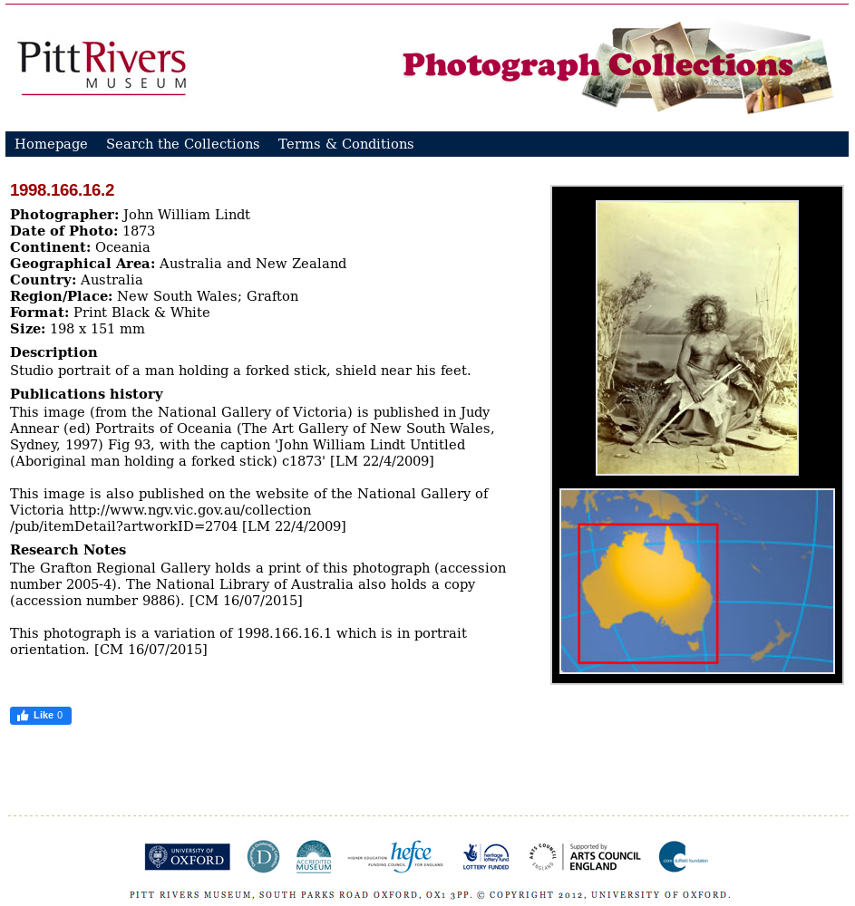

An “original” image as displayed on the Pitts River Website. Though originally denying access to their images, they later decide to permit their use. The photographer, John William Lindt, died in 1926 thus legally placing the photograph in the public domain.

The photographs were then taken out of their ‘original’ or institutional categories (often geographical) and regrouped into my work chapters defined by striking similarities in how they were composed. Each chapter comprises photographs from all colonized continents. The chapters get called Strong Looks, the White Man in the Group, Awkward in the Studio, Exoticism, etc.. some of these names became the later Chapter titles.

ROKIA: J’étais curieuse de savoir comment Antje allait re-classer, re-classifier, re-catégoriser ces hommes, ces femmes, ces enfants, comment allait-elle les phagocyter, comme une amibe, et comment allait-elle les montrer pour que tout un chacun puisse les voir, pour que les gens puissent se poser ma question, POURQUOI?

Je me suis synchronisée à elle, je l’ai observée dans son travail au labo, j’ai capté les sons de ses machines, de sa voix, de sa respiration dans le noir quand elle manipulait sa matière, je savais que c’était la partie la plus importante pour elle et pour moi. Je me suis imprégnée de ses doutes, de ses victoires, de ses expériences ratées ou réussies, je l’ai écouté faire, je l’ai simplement écouté créant ainsi ma propre base de données sonore.

Ce temps long et lent fut nécessaire pour construire mon propre socle. La base de ce que j’allais produire pour dialoguer sonoriquement avec les films, avec les images, avec ces archives. Il m’a fallut me nourrir de sa pratique pour trouver mon fil conducteur, retrouver mes sens auditifs pour simplement lui répondre et compléter notre dialogue, notre narration.

PEGGY: Cette question de la taxonomie me parait centrale dans cette démarche de réappropriation de ces archives. Les anthropologues, souvent entrepreneurs religieux ou économliques de la colonisation, dans la première période de construction de ces savoirs, n’ont cessés de classer, ordonner, nommer, construisant des réalités, les détournant, les figeant, avec des conséquences, pensons au Rwanda, autre territoire de colonisation belge, mortelles ouvent, délétères, toujours. Pensons aux hierarchies de la noirceur et comment elles ont servies à incarner (rendre dans la chair) les hierachies sociales en associant les classes mulâtres aux classes moyennes, avancées et aux contremaitres des plantations et reléguant au fond des champs, sous le joug des sévices les plus déshumanisant, les personnes les plus noires. Recatégoriser, c’est aussi réinvestir ces images de leur historicité, redonner une humanité, un agentivité à ces personnes figées sur papier. Je pense notamment à la catégorie regards forts, strong looks. Sur cette question des catégories et leur matérialité, il est difficile de ne pas penser aussi à leur utilisation par la dictature sud africaine durant les longues années d’Apartheid.

ANTJE: I get the chance to show work in the Vitrine of Constant vzw[2], an organization for art, media and feminism. To project film there is not an option, so I decide on an installation form. I take the many rushes of my tests and hang the filmstrips behind the window, installing flourescent lights in the back. On the street side, cables are strung carrying magnifying loupes. The installation provides a private, active way of looking which suits the material well.

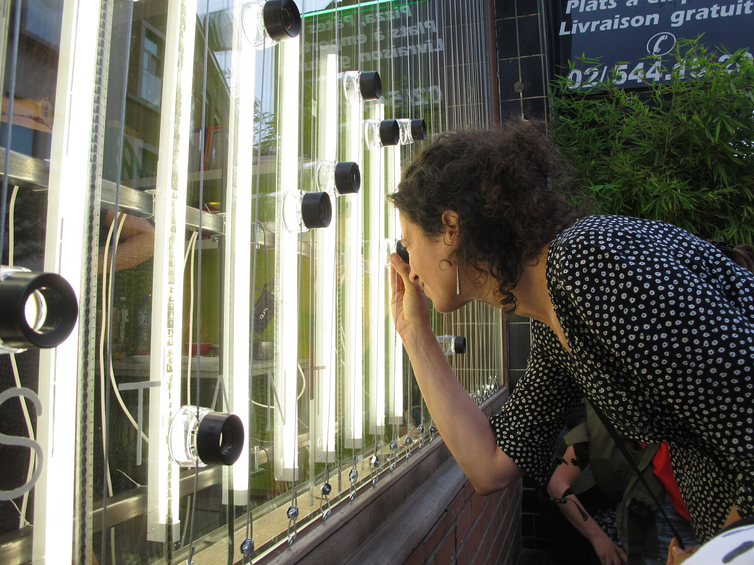

Image: Femke Snelting, Free Arts License

A first version of Chapter 1 Strong looks is ready. I ask the publics help to identify images I am not allowed to use, and burn these images on the projector. The resulting action feels very violent and is never repeated. As Constant’s **Femke Snelting** put it: “It puts the agression in the wrong place”.

## 2017_

ANTJE: In February I’m showing rushes at l’Etna, an artist-run lab with a rich debate culture in Montreuil. I invite Paris artist-activists Pascale Obolo and Michelange Quay. This night turns into a lively debate which triggers the next move.

With **Loes Jacobs** I set out a research path to reflect and debate my work with the public. We get some funding and I set out to handpick atmospheric places where these debates will take place. As every debate will present a new chapter, with a few weeks in between, the work advances at high speed.

LOES: Antje asked me if nadine[3] wanted to be a partner in the process of presenting her films to an audience. The idea of organising debates around the viewing of her films, interested and - at the same time - scared me. Would we be able to reach a diverse enough audience (in terms of cultural background, class, age, etc) to hold such a discussion?

From the very beginning it was clear this was going to be a collective process, gathering as many voices as possible around a theme that concerns everyone, but is hardly addressed in our society. The archives from the musea including the Africa museum in Tervuren are silent and hidden witnesses of a history that is barely addressed in Belgium.

*If society fails to address colonial history, and structural racism, can artworks, and the spaces where they are presented, offer the necessary openness, empathy, generosity, and care for dialogue?* Where were relevant spaces that could hold a conversation on images from the past having an impact on lives today? We connected very organically to different cultural spaces that were willing to host our screenings and debates. All evenings were fully booked. There is a need in Brussels to talk about colonial history and the artworks by Antje and Rokia triggered intense debates.

ANTJE: I look for speakers and a moderator who are not white. I feel a strong need to discuss the topics of this work with a public as mixed as possible. I meet with **Peggy Pierrot** who is already deep into the studies of antiracist activism and art. I am impressed. She agrees to moderate the debates. The aim is to discover the work through the eyes of the public and to know what forms and elements of contextualization are needed. We learn from the most urgent questions, often about the intention and positioning of the artist, the need of a framework. These questions lead to adding the chapter titles and subtitles in the work, and the writing of an exhibition text.

PEGGY: Throughout the process of the creation and presentation of the artworks the question of regaining power, shared among the race and colonial power lines have been at the center of the work. Regaining power on the black bodies, regaining power on history, regaining agency on both side of the color line. I’ve been struck by Antjes parents comments at the first debate: “At the time (of colonialism), seeing those images was normal. Seeing them today is just terrible.” I felt like they also have been denied agency about the big others as their own relation have been mediated by the colonial power gaze through schools, press and other dominant culture apparatus. *How can an artist work on different filthy hidden image archive could have been throughout a collective process an attempt for questioning powers and lack of power and in the same time a tryout of building a new collective agency for the shared futures?*

ANTJE: In this same period of time Rokia creates a soundpiece reacting on Chapter 03_Numbers and Comments.

ROKIA: J’étais fascinée par ce chapitre 3. Les chiffres et les commentaires m’ont beaucoup choquée! Les annotations descriptives encore plus… que faire avec ce trop plein d’émotions? Mon processus de création s’est enclenché comme une évidence, je voyais mes sons apparaître clairement devant mes yeux, et oui, c’est une méthode assez particulière! Je construis une ligne de sons. Cette ligne sinusoïdale, je la visualise d’abord pour la reconstituer point par point.

J’ai enregistré le chuchotement, les cris de ma fille scandant des mots et des chiffres ainsi que la mienne, je les ai mélangé aux bruits d’enregistrement de Antje en plein travail, on entend des respirations, des sons de la nature également, des oiseaux surtout pour nous préparer à découvrir un chapitre au défilement de photos particulièrement difficiles à voir!  
Il me semblait important d’y faire contribuer ma fille car sa voix douce et fragile s’intégrait parfaitement à cette nouvelle narration naissante.

## 2018_

ANTJE: From the question ‘how to engage the viewer even more with this material?’ and the thought that recognition is an important step, combined with the desire for a public inquiry into the archives, the ideas for a new installation, The Recognition Machine, are developed. It should be a photobooth that turns out *the wrong picture* and creates a special bond with somebody from the colonial past. Instead of your own portrait, you receive a translated image from the troubled archives. You are then invited to do research on this image.

Michael Murtaugh agrees to develop this installation, together with Nicolas Malevé under the collective ICV[4]. After a public test with a few existing models combined (age, gender and emotion) we decide to focus on the emotional recognition.

This is the first time in my life that I think of archival material in terms of emotion. (Visiting artist **Gosie Vervloesem**)

MICHAEL: Antje knew of my work with the collective ICV and we had both exhibited in the same streetside gallery. In that installation, we had used facial recognition to replace the faces of passersby with “misrecognized” faces from the photos of the objects of another archive. For us the inclusion of “misrecognitions” and errors are an important way to talk about what these algorithms actually are doing, beyond simply what they claim. For the Recognition Machine, the model we ended up using, FER2013, takes an image of a face, and gives a “prediction” of what emotion that face appears to be displaying. These models are not “pure algorithms” but in fact are the product of a being trained with thousands of examples, images that have been given labels like “happy, neutral, angry, and disgusted”. FER2013 itself is a troubled archive, created by university students for a computer science competition that stipulated that the images not be part of an already existing collection. As a result, the researchers used Google image search to perform automated searches to produce the collection. But who has made these subjective judgments? To answer why exactly is is that, among the 30,000 collected images, a photo of actor Samuel L. Jackson appears among the examples of “angry” is complex. When producing an intepretation of a new image, the data model reflects the training data and how and who created it. In this work, we wanted to draw a parallel between contemporary data and surveillance practices with those of the colonial photographic projects Antje was critiquing.

ANTJE: The translation of the racist archival images into portraits is a thrill. I turn the Bolex camera to obtain a vertical portrait format. I look for the frame in which each person gains agency: to put a face higher, lower, more to the left or the right makes a dramatic difference. I undo the exoticizing elements: I want the portraitees to become timeless and universal - I want the visitor to feel as if they could meet this person around the corner.

I ask **Brenda Bikoko** to rename the images to preserve the link to the archive in the Recognition Machine. As a trained Art Historian and someone from a mixed background, having confronted racism in her own life, her involvement was important.

BRENDA: Having the opportunity and privilege to dive into that many images from different renowned archives, I was able to look at pictures the way Ariella Azoulay proposes in *The Civil Contract of Photography*. Every picture is worth being questioned.

*What’s the gaze of the subject(s)? What’s the position of the mouth? Can I interpret some kind of body language? What’s the topos in the image? Who’s absent in the image?*

I have seen pride and I have seen deep sadness.

Capturing the gaze of the portrayed, I never perceive someone less than me. The portrayed is someone different from what we’re used to looking at. He or she is mostly from another period in time. As photography is not that old, we’re talking of a recent past. When archive images find their way into an artists’ creative strategy like Antje’s there is the opportunity to be a graceful subject, to be examined, to be meaningful, to be recognized, to be reconciled.

Graceful as in being different and beautiful. Examined as a study object the archive image also provides a personal experience. The archive image is meaningful in the shift from being part of a static data collection to being part of different dynamic contexts, recategorization, debate, engagement, processes, affection, …. The shift explains the archives root of existence if the institution allows it. Going through positive manipulation Antje helps us discover or remember a hidden construction of a colonial and imperial past through acknowledging and shaping. Using traditional celluloid filming for re-photographing or re-filming, the images and portraits often get blurred or made imperfect. When looking and asking yourself “what’s the gaze? what’s the position of the mouth? etc.”, there will not always be an answer. Some of us experience it as a frustration, others may interpret it as colonial history and like the fair re-use even better than the original. Antje uses bits and pieces of archives, and in a way it helps us to better understand reality. Going into the *Recognition Machine* and taking part in it, may result in an appointment with your present -self, the past and our future reigned by computers and algorithms.

Recognize if you can, look, question and debate. Feel related by far, closely, or not at all. Past, present, and the consequences for the future have a political dimension. In essence, it should be looking for justice, a better world and last but not the least transgenerational reconciliation in its very own way. Dealing with these issues is at the same time as easy and as hard as it can get. *Troubled Archives* became a model for reconciliation, but only if you’re willing and aiming to.

## 2019_

ANTJE: I was invited by curator Lucia Halder from the Rautenstrauch-Joest museum, to take part in the Photoszene festival in Cologne, Germany. together with Michael and Rokia we presented the installations NOISY IMAGES and The Recognition Machine.

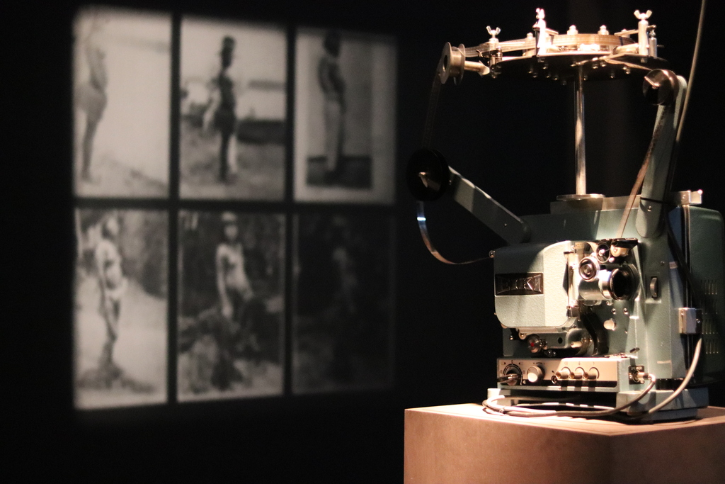

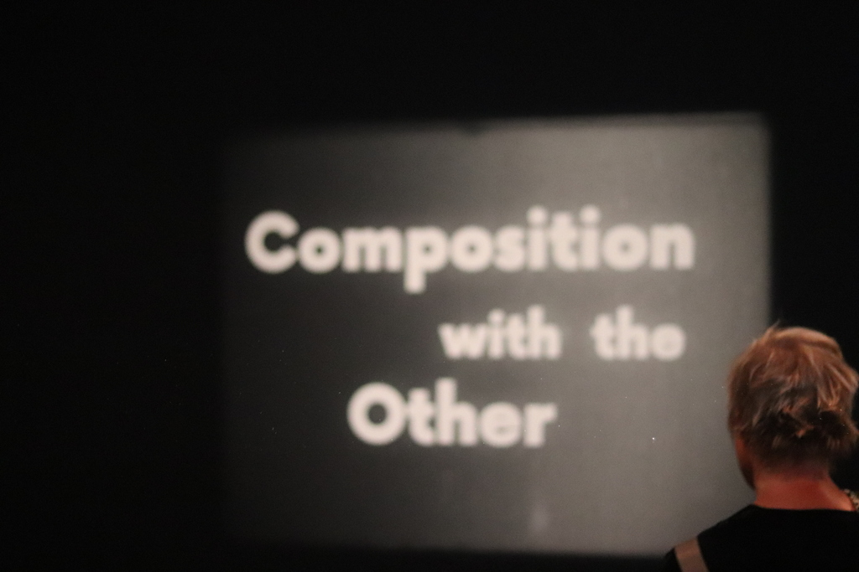

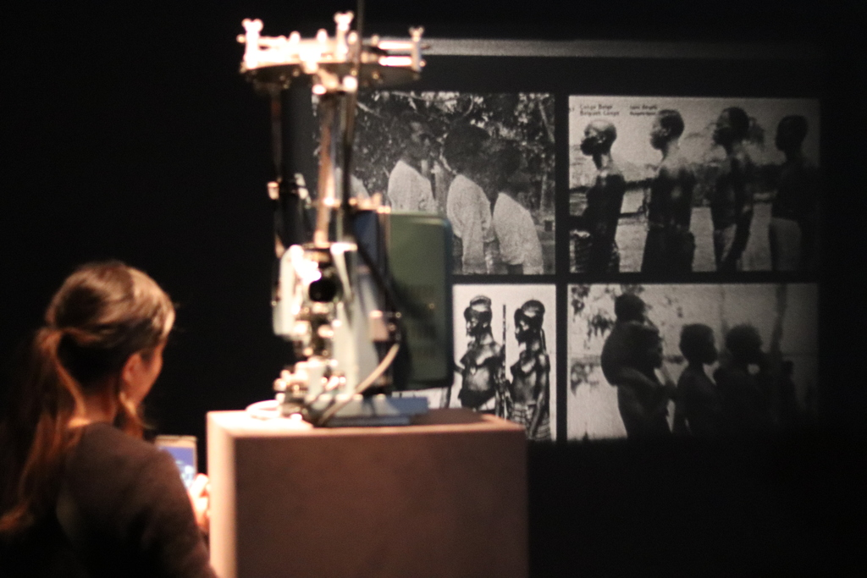

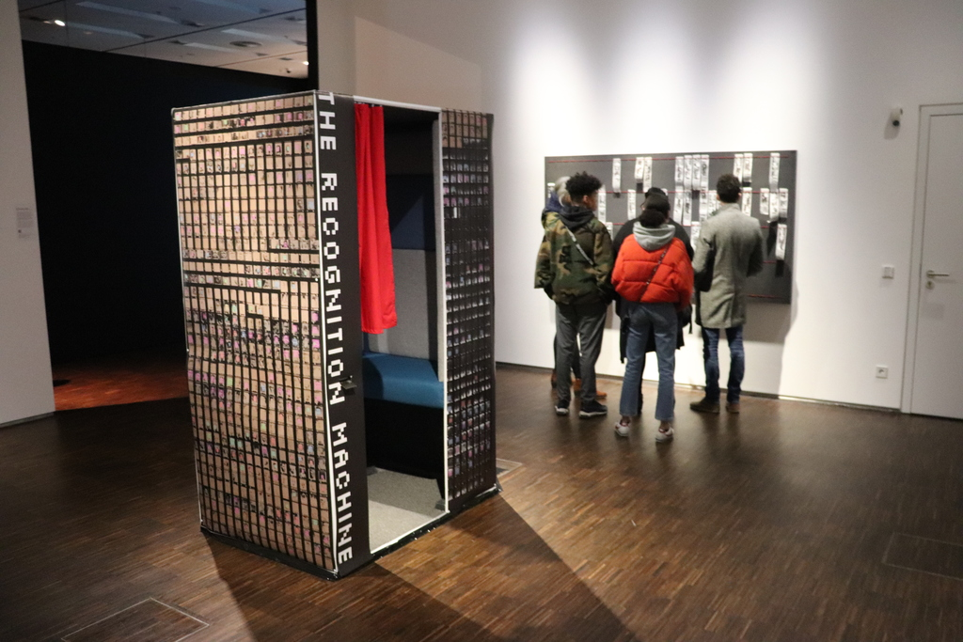

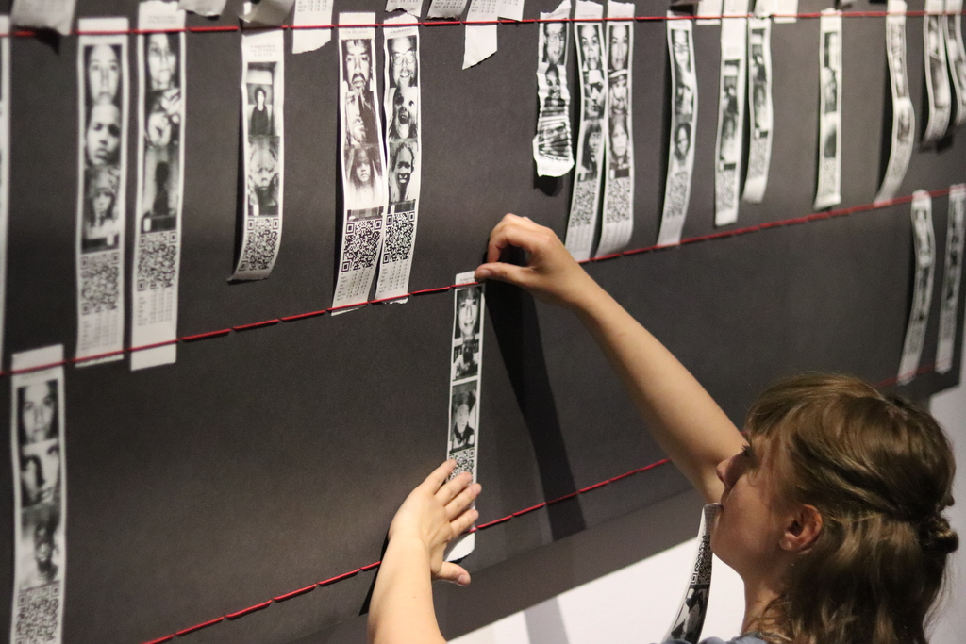

Images: Massimiliano Di Franca, Free Art License

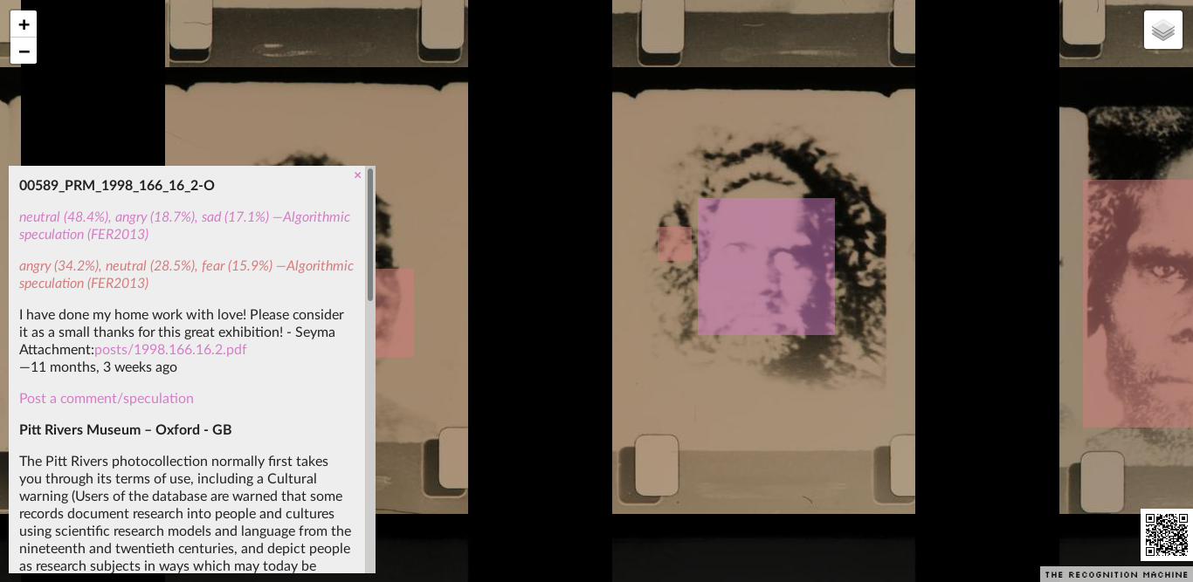

Response posted to the website[5]

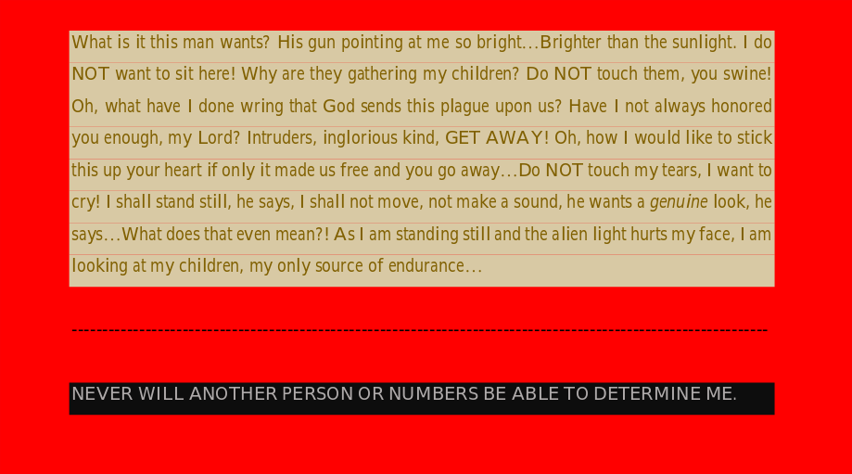

Detail from uploaded PDF

MICHAEL: When testing The Recognition Machine in Köln, Rokia and Antje enter the photo booth and have their picture taken together, but only Antje’s face is recognized; Rokia exclaims: “your machine is racist”. I think: yes, this is what we want to talk about, but not like this. On the morning of the artist talk event, before leaving for Köln I log in remotely to the exhibition computer to make a backup of the collected photographs. In this “archive” of digital photos, each visit to the installation is recorded as a digital photo, with a super-imposed rectangle indicating where faces were detected. Though not intended as such, the installation acts as a surveillance device, each visit dutifully recorded and named using the date and time. I click through image after image, each time with a rectangle highlighting the face, until, the face of a woman, in a head scarf leaning slightly back away from the camera. Her face is not recognized. Then again, scores more images as before, young faces, older faces, each recognized, but predominantly white. Finally, I reach the end of the photos and the very last is of a black man who’s face I recognize as a guardian who works for the museum. His photo was taken around 7 in the morning before the museum had opened. Though he stares directly into the camera lens, his face is not recognized. For one with a lived experience of racism, the failure to be recognized repeats a violence, however inadvertant, echoing earlier exclusions now embedded into a software model. The confirmation that an algorithm has racial biases built into it, may seem a “revelation” to me, the white programmer – in the repetitive use of the software I’ve been trained to accept the algorithm’s claim of “face recognition” and as something “natural” and “working”.

For me, you can leave out the photobooth entirely, the panels with the displayed images of the visitors is the strongest image. **Cédric Kouamé**, participant in the Artist talk, Rautenstrauch-Joest museum

ROKIA: Mon expérience au musée fut très confrontante, avec Antje nous avons construit la salle d’expo avec des legos, pour ensuite la transposer scénarifiquement sur une échelle réelle, avec des enceintes en stéréo et en mono, elles étaient placées à des endroits stratégiques en dialogue avec les projecteurs, toujours en dialogue une cacophonie choisie, voulue et assumée. Nous étions tous ensemble, Antje, Michael et Loes… Nous ne formions qu’un! Chacun étions occupés et conscient(e)s de l’enjeux de nos créations dans un musée coloniale! La déconstruction était en marche. La mise en place sonore ne fut pas à mon sens parfaite j’aurais voulu plus de bruit et plus de considérations sur la nécessité et l’utilité des moyens sonores! Le son, le bruit, n’ont malheureusement pas encore leurs places dans les musées; c’est aussi un art, et qui ne demande qu’à éclore. Ce genre de contexte s’y prête bien, encore faut-il qu’il soit compris, entendu? Notre but était de surprendre, de faire émerger, ressentir, l’état émotionnels de ces gens photographiés par la force, mon but était de faire surgir ces états internes pour que les gens puissent s’exprimer et débattre par la suite…

LOES: The setting of the Rautenstrauch Joest museum was very different from the small spaces in Brussels that hosted the debates. In this enormous museum the colonial history feels static to me with the collection of objects displayed in glass vitrines. Presenting Troubled Archives here was a big step and offered the artists and the works an important platform. Yet I still wonder. *Was enough effort given to highlight the importance of dialogue. Does the presentation of contemporary artworks in this context not also become yet another object alongside those in the sealed display cases?*

## 2020_

ANTJE: Both installations - Noisy Images and The Recognition Machine - are selected to the Dakar Biennal and will be on view at Fondazione Sandretto Re Rebaudengo in Turin, 17 September to 18 October 2020.

ROKIA: Nous sommes les seuls belges à avoir été sélectionnée pour la Biennale de Dakar, nous en sommes fières; une autre porte s’ouvre à nous, d’autres narrations vont pouvoir se créer, se raconter à traver notre travail respectif et collectif.  
Les rapports aux corps de l’Autre, de la nature de l’Autre, de l’image de l’Autre vont faire surgir des cadres de références multiples, j’ai vraiment hâte d’entendre les récits qui se dégageront à la vue de notre exposition.  
Le plus important à mon sens, c’est d’assister aux échanges sur les perceptions, sortir de sa zone de confort…

PEGGY: Le travail proposé par Antje ne peut et ne doit pas être diffusé de manière morcelée. Les discussions, les cartels, les textes, les son, tout a son importance et l’oeuvre c’est le tout, ce dispositif discursif, cet appel du pied à remettre du contexte et du sens, ramener les âmes flouées à la vie en 2020 en insistant sur ce qui a permis la production de ces images, ce à quoi elles ont servies. On oublie souvent l’ampleur de leur diffusion, à travers la presse, les cartes postales, et comment elles ont conditionné le regard des populations colonisatrices, mais aussi celles des colonisés.

LOES: A work of art based on colonial archives can become a vehicle for discussion and transformation. What is important, I think, is that the work itself embodies a certain openness for change, and therefore must be willing to (or the maker must be willing to) absorb the comments it triggers. Every moment of presentation therefore becomes a new version of showing the work. Each new version also transforms the archives it is based on. We cannot know where this will lead (possibly to the erasing of the archives). Where the archives offer us a passive and static testimony from the past, an artwork is a producer of meaning, and therefore has the power to (re)tell the story of that testimony, and can become an active witness.

These ‘transformative works’ form to me an ideal basis for collectivity. Inviting other people to join the artistic process can eventually lead to the structure of a platform, as it happened for Troubled Archives. The artwork as a static object then shifts to a collection of multiple pieces, and the artistic process becomes a collective discussion. I hope this article will inspire others to demand access to the archives, as filhty as they can be, and use them to tell new stories.

PEGGY: La valeur ajoutée du regard artistique sur l’archive (et on entend le regard artistique vu comme un processus collectif, dynamique et relationnel initité et médié par une personne dont la qualité d’auteur est reconnue sans qu’il soit question d’une exceptionnalité originelle, mais bien le fruit d’un parcours, de pratique, de techniques et de positions sociales) nous intéresse en ce qu’il permet de pointer du doigt et d’ouvrir un espace de prise de conscience, de mise en lien et de discussion que les territoires dominants de la conflictualité politique se refusent d’adresser, pris qu’ils sont dans la toile du système de justification des rapports de production capitaliste. Nous pensons par exemple à la place de l’exploitation du corps des Autres, et la division corporelle et raciale du travail dont la réalité crue n’est dénoncée que par quelques syndicats ou associations militantes. A travers les dispositifs mis en place dans le projet Troubled Archives, des activistes décoloniaux croisent des amateurs d’art, des passants désœuvrés, des travailleurs subalternes de passage (etc.). Et tous peuvent voir se dérouler sous leurs yeux le continuum qui lie les corps exploités d’hier à ceux d’aujourd’hui.

(…) Maybe then one day my work can lay forgotten in some archive. Transforming into something else. (Antje Van Wichelen)

1. <http://www.primitives.constantvzw.org/2011/02/20/the-nigger-is-in-the-shrank/>
2. <http://constantvzw.org/site/21C-19C-Procedures-for-Anthropometric-Image-Reversal-Finissage.html>
3. <http://nadine.be>
4. Institute for Computational Vandalism <http://vandal.ist>
5. <https://recognitionmachine.constantvzw.org/#6/-164.008/63.719>